Mobile log upload

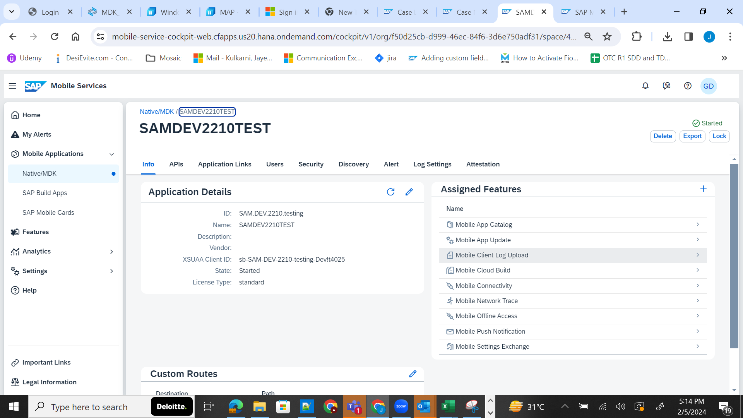

Check this log upload box and save.
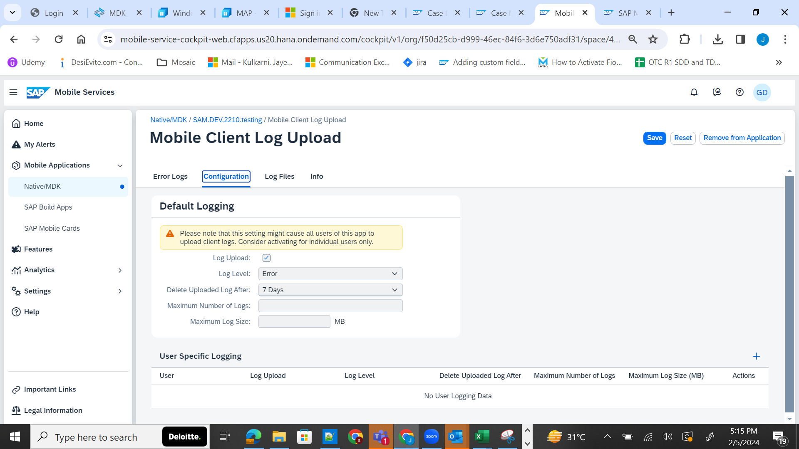

In your code write Logger.error(error) in catch block and deploy

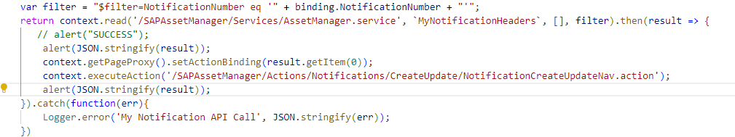

Go to profile settings >> support >> send Log (error)

Go to log files and download and search by “My Notification API call” in the downloaded file.

